**Experiment-1**

**Aim: - To design a Test module for an Amazon Web Application**

**i)Home**

**ii)Sign in Page**

**iii)Product Details**

**iv)Payment**

**Summary: -**

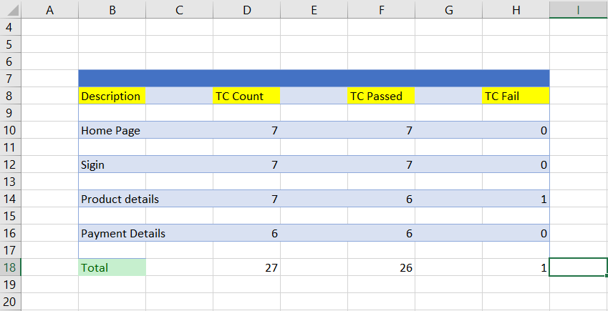

**i) Home Page**

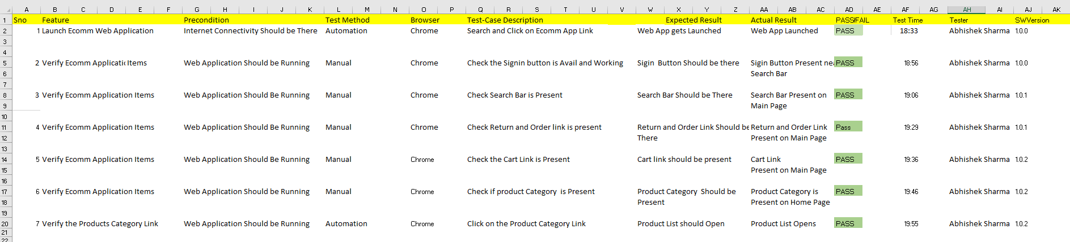

**ii) Sign In Page**

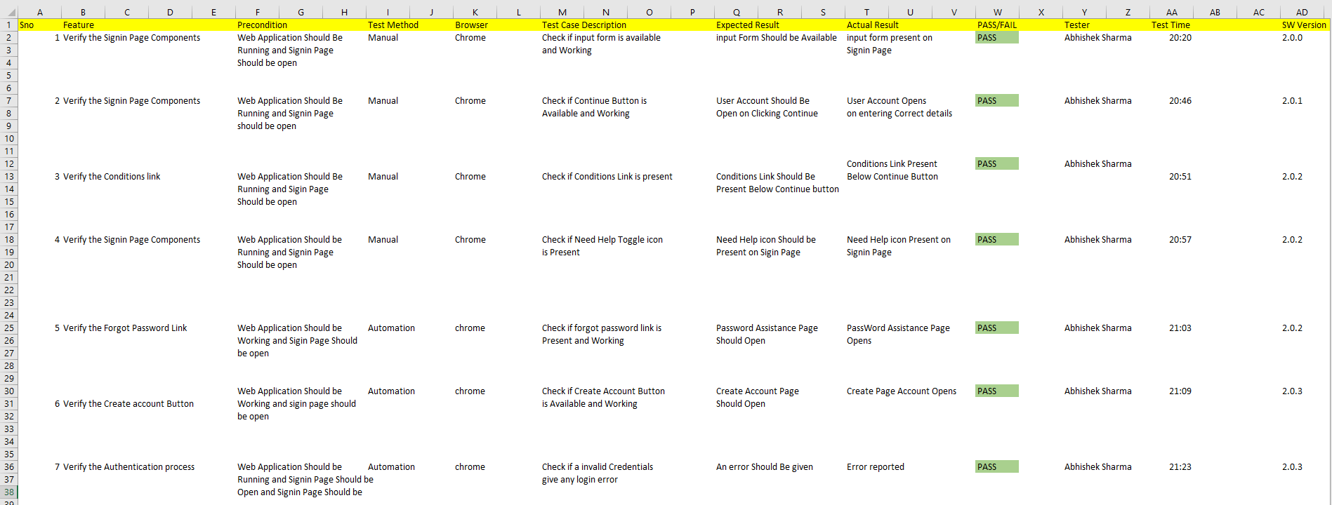

**iii) Product details**

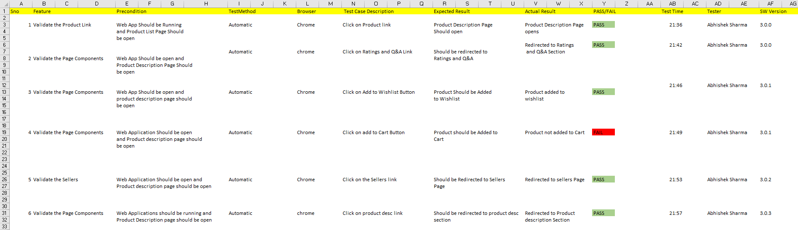

**iv) Payment Details**

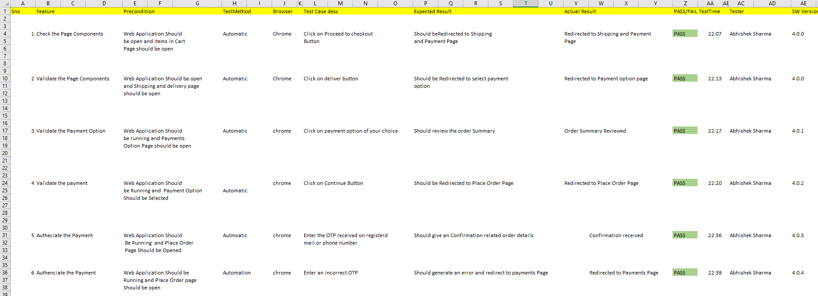

**Experiment – 2 & 3**

**Aim: Build an automation script for registration and login for eCommerce platform.**

**1) Login**

**Code:**

package testSelenium;

import org.openqa.selenium.By;

import org.openqa.selenium.WebDriver;

import org.openqa.selenium.WebElement;

import org.openqa.selenium.chrome.ChromeDriver;

public class EXP_2 {

public static void main(String[] args) throws InterruptedException {

// declaration and instantiation of objects/variables

System.setProperty("webdriver.chrome.driver", "C:\\Users\\dell\\Downloads\\Drivers\\chrome\\chromedriver.exe");

WebDriver driver=new ChromeDriver();

// Launch website

//driver.get("https://www.amazon.in/");

driver.navigate().to("https://www.amazon.in/");

// Click on the search text box and send value

WebElement element = driver.findElement(By.id("nav-link-accountList-nav-line-1"));

element.click();

WebElement email = driver.findElement(By.id("ap_email"));

email.sendKeys("8077490375");

WebElement cont = driver.findElement(By.id("continue"));

cont.click();

WebElement pass = driver.findElement(By.id("ap_password"));

pass.sendKeys("AbhisheK");

WebElement signIn = driver.findElement(By.id("signInSubmit"));

signIn.click();

WebElement search_text = driver.findElement(By.id("twotabsearchtextbox"));

search_text.sendKeys("MI 10t pro");

WebElement search = driver.findElement(By.id("nav-search-submit-button"));

search.click();

WebElement select = driver.findElement(By.className("a-size-medium a-color-base a-text-normal"));

select.click();

}

}

**Screenshots:**

**1) Searching www.amazon.in on web.**

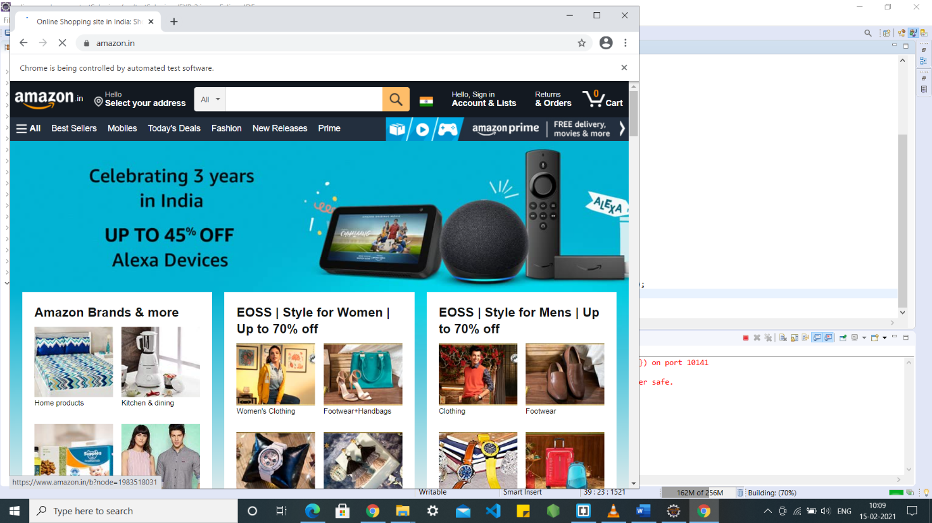

**2) Clicking on the log in button**

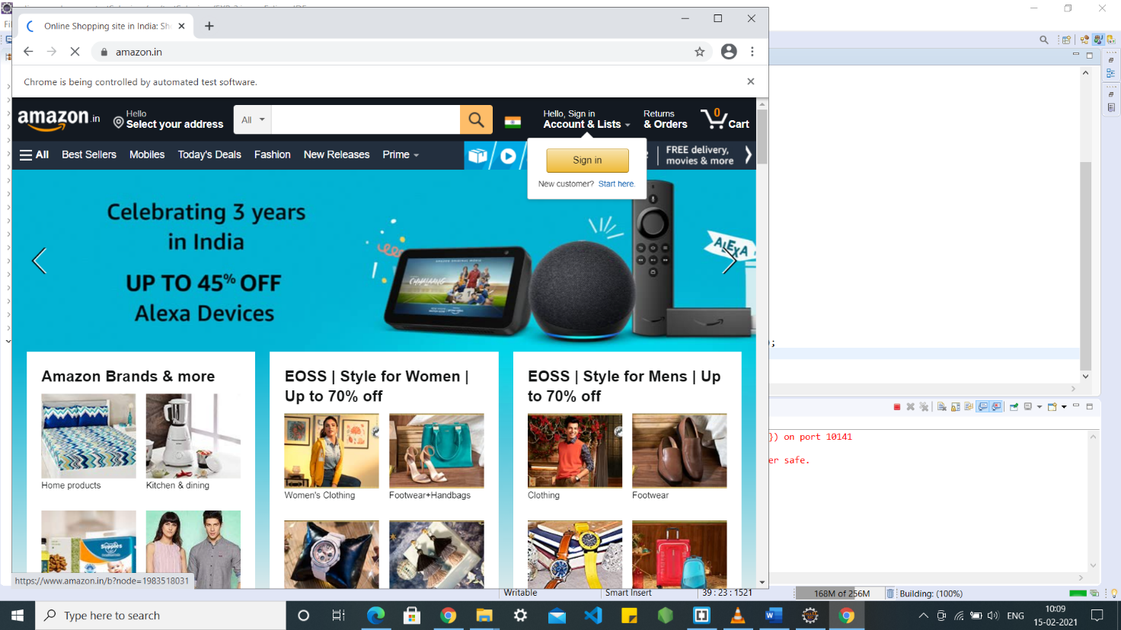

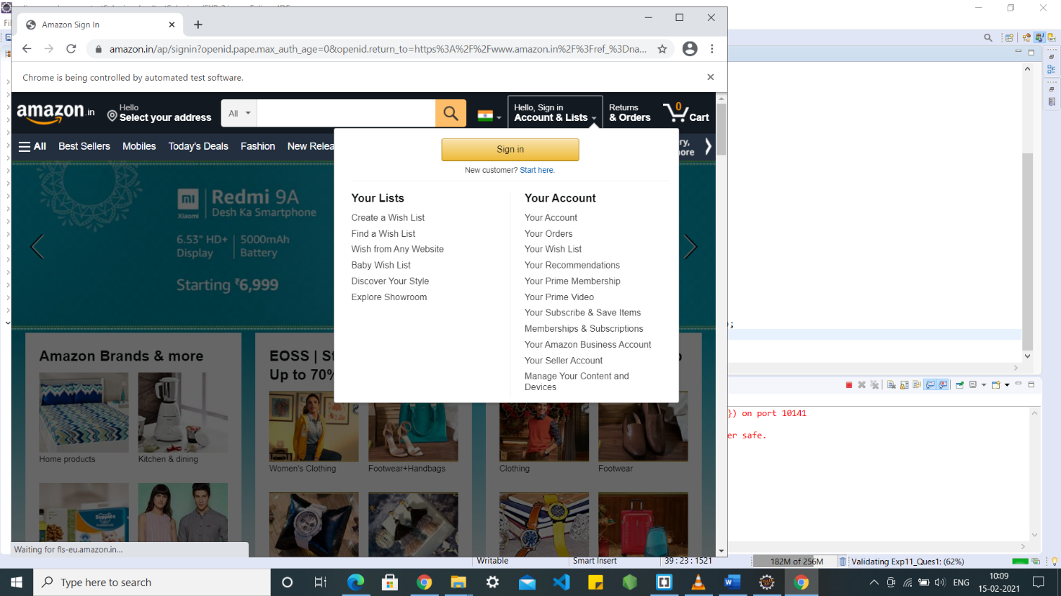

**3) Entering email and password**

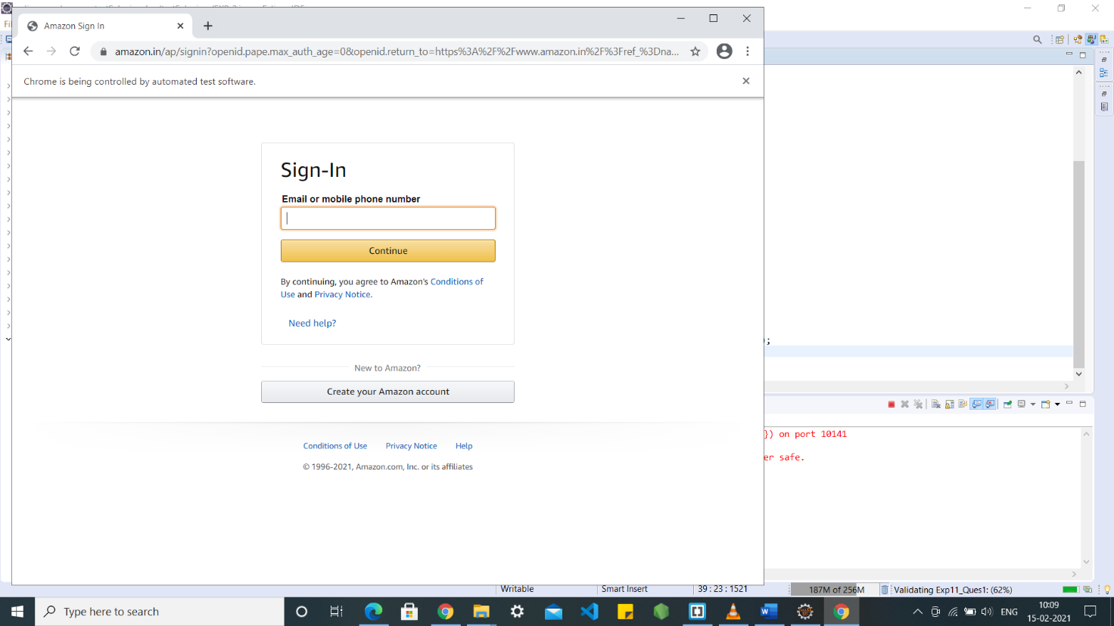

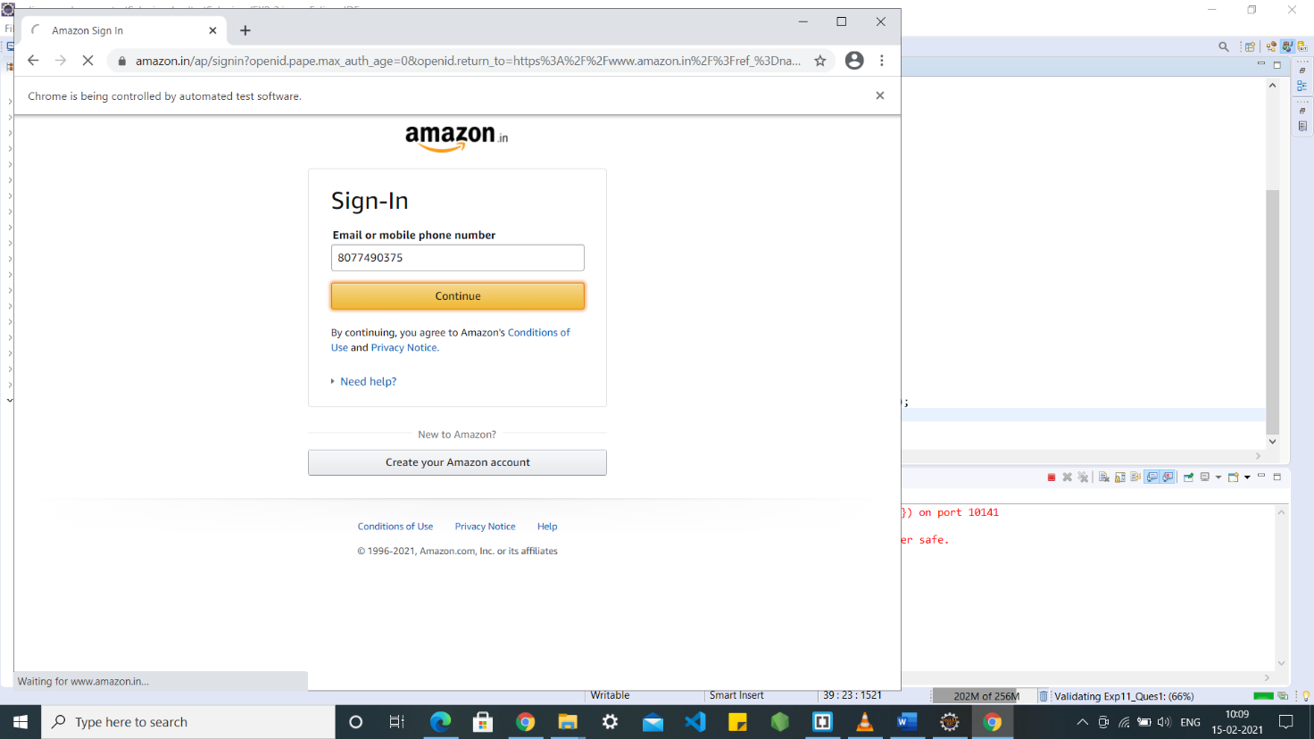

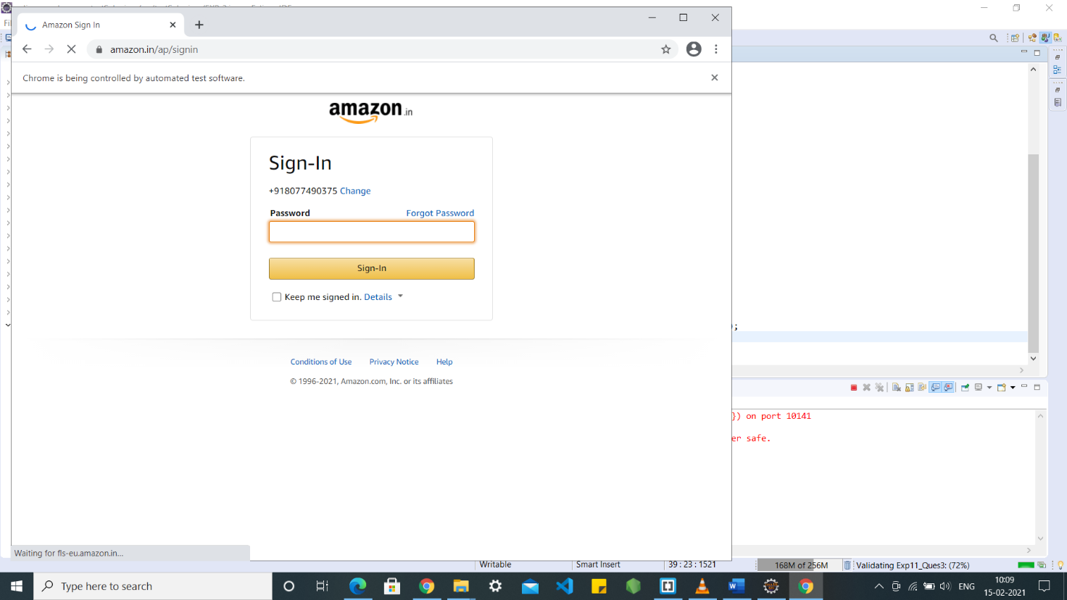

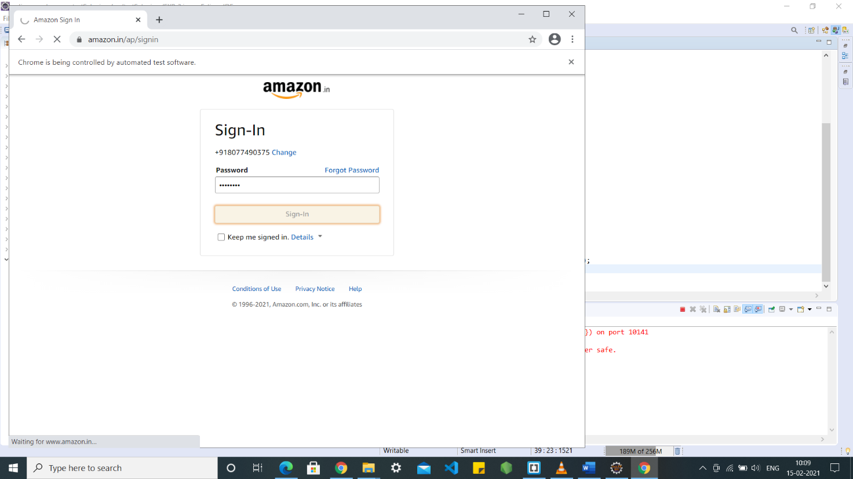

**4) Clicking on submit**



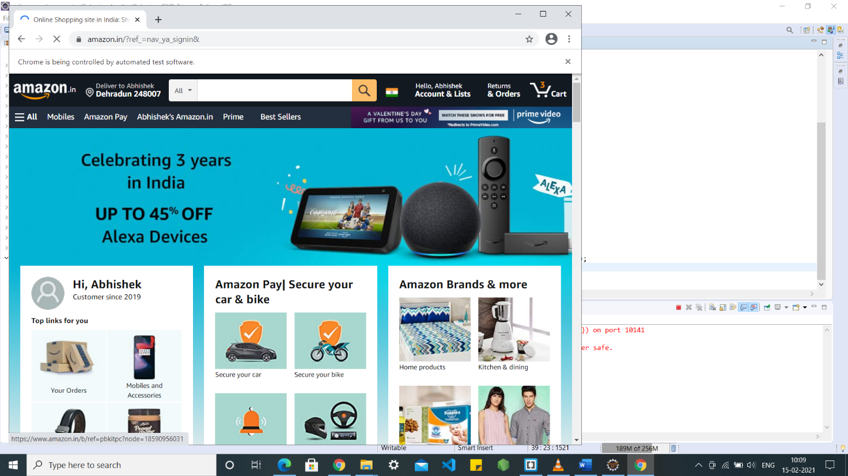

**2) Registration**

**Code:**

package testSelenium;

import org.openqa.selenium.By;

import org.openqa.selenium.WebDriver;

import org.openqa.selenium.WebElement;

import org.openqa.selenium.chrome.ChromeDriver;

public class Register_Class {

public static void main(String[] args) throws InterruptedException {

// declaration and instantiation of objects/variables

System.*setProperty*("webdriver.chrome.driver", "C:\\Users\\dell\\Downloads\\Drivers\\chrome\\chromedriver.exe");

WebDriver driver=new ChromeDriver();

driver.navigate().to("https://www.amazon.in/");

WebElement hellosignin = driver.findElement(By.*id*("nav-link-accountList"));

hellosignin.click();

WebElement acc = driver.findElement(By.*id*("createAccountSubmit"));

acc.click();

WebElement name = driver.findElement(By.*id*("ap_customer_name"));

name.sendKeys("Abhishek Sharma");

WebElement number = driver.findElement(By.*id*("ap_phone_number"));

number.sendKeys("877490375");

WebElement pss = driver.findElement(By.*id*("ap_password"));

pss.sendKeys("AbhisheK");

WebElement con = driver.findElement(By.*id*("continue"));

con.click();

} }

**Screenshots:**

**1) Going to www.amazon.in**



**2) Clicking on the button to register**

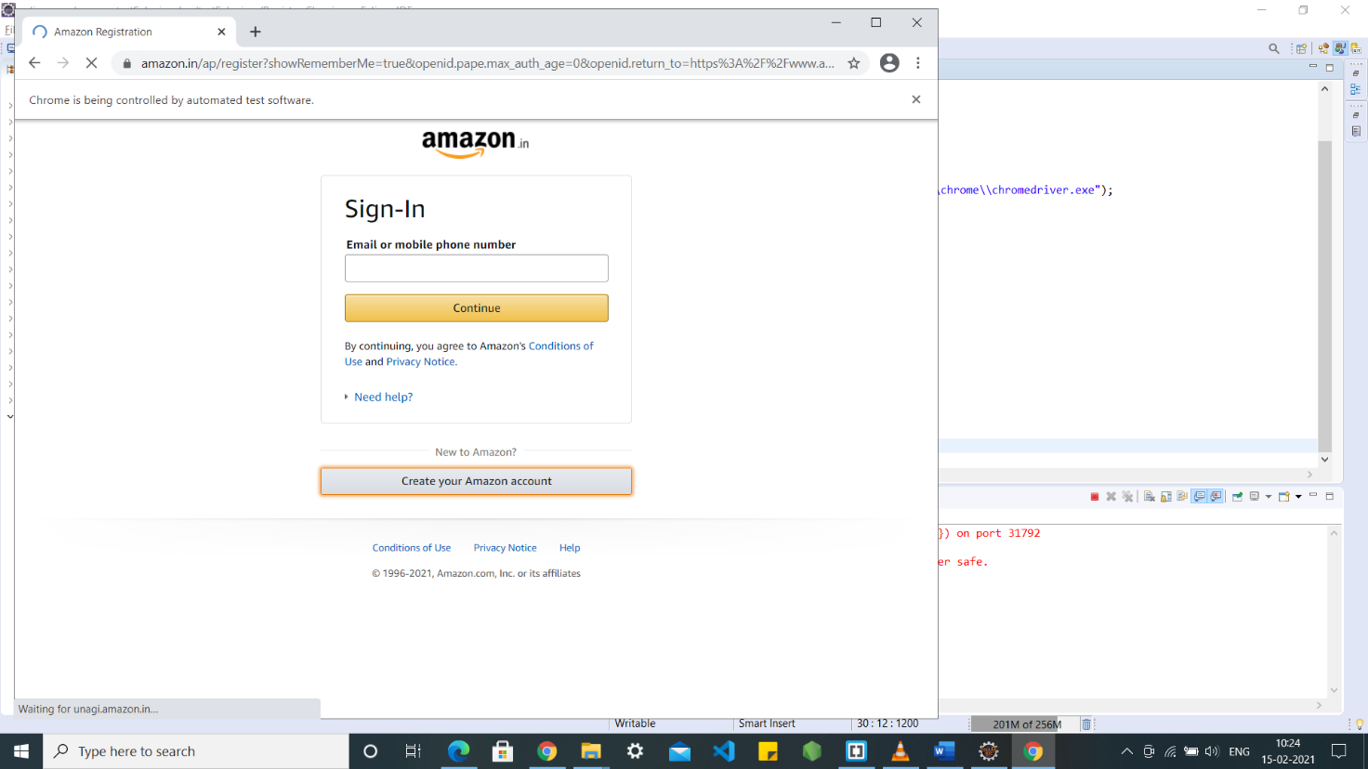

**3) Entering details and pressing continue**

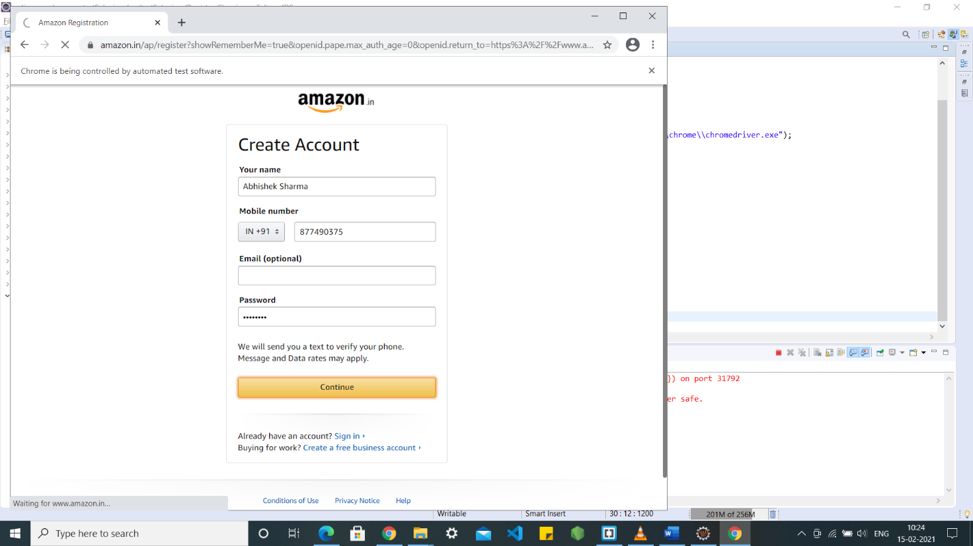

**EXPERIMENT – 4**

**Aim:** Build an automation script for searching the article and validate the searching of the article.

**Code:**

import org.openqa.selenium.By;

import org.openqa.selenium.WebDriver;

import org.openqa.selenium.WebElement;

import org.openqa.selenium.chrome.ChromeDriver;

public class Exp4 {

public static void main(String[] args) throws InterruptedException {

// declaration and instantiation of objects/variables

System.setProperty("webdriver.chrome.driver", "C:\\Users\\dell\\Downloads\\Drivers\\chrome\\chromedriver.exe ");

WebDriver driver=new ChromeDriver();

driver.navigate().to("https://www.amazon.in/");

// Click on the search text box and send value

WebElement searchbar = driver.findElement(By.xpath("/html/body/div[1]/header/div/div[1]/div[2]/div/form/div[2]/div[1]/input"));

searchbar.sendKeys("Iphone 11 Pro");

WebElement searchbutton = driver.findElement(By.id("nav-search-submit-button"));

searchbutton.click();

WebElement name = driver.findElement(By.linkText("Apple iPhone 11 Pro (64GB) - Space Grey"));

name.isDisplayed();

WebElement price = driver.findElement(By.xpath("/html/body/div[1]/div[2]/div[1]/div[2]/div/span[3]/div[2]/div[2]/div/span/div/div/div/div/div[2]/div[2]/div/div[2]/div[1]/div/div[1]/div[2]/div/div/a/span[1]/span[2]/span[2]"));

price.isDisplayed();

WebElement image = driver.findElement(By.xpath("/html/body/div[1]/div[2]/div[1]/div[2]/div/span[3]/div[2]/div[2]/div/span/div/div/div/div/div[2]/div[1]/div/div/span/a/div/img"));

image.isDisplayed();

driver.close();

}

}

**Screenshots:**

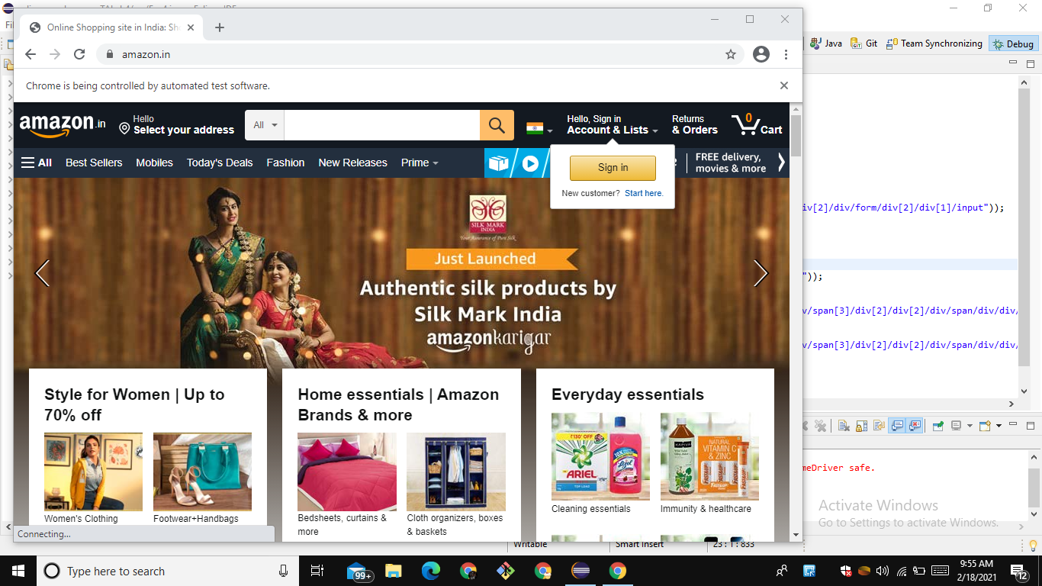

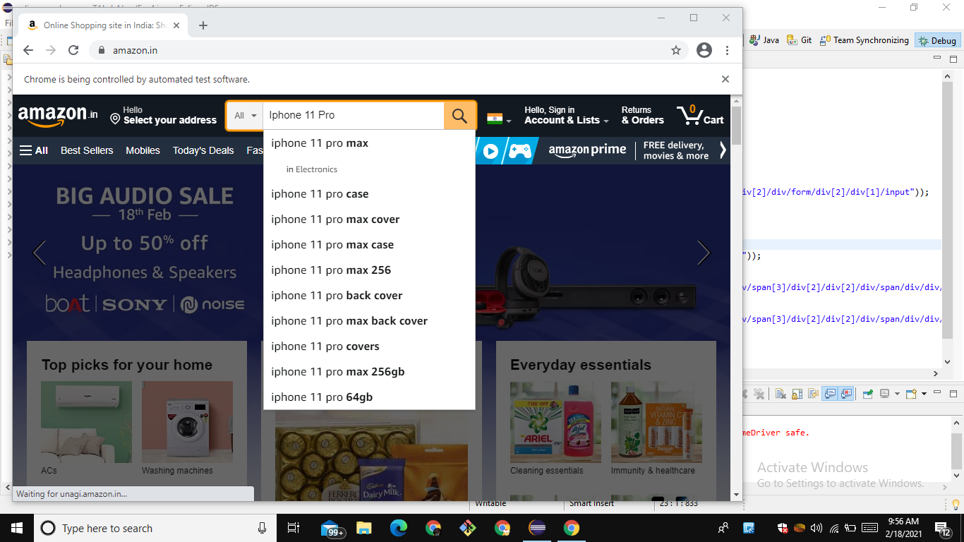

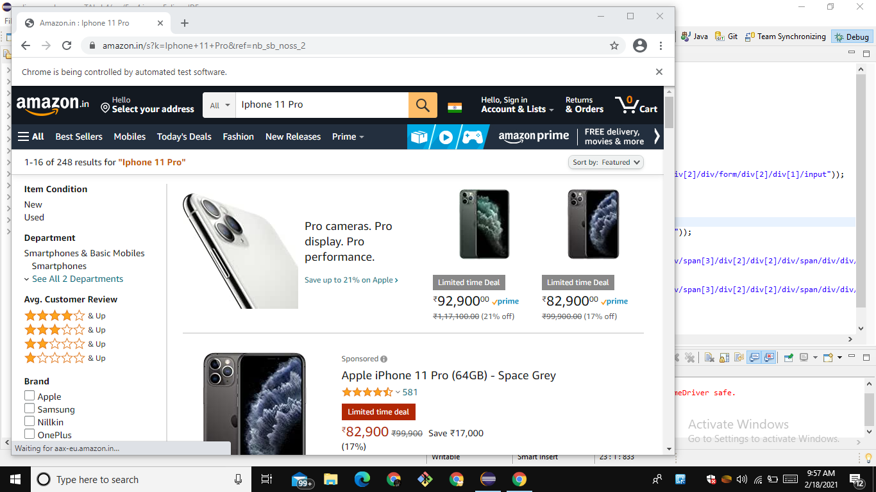

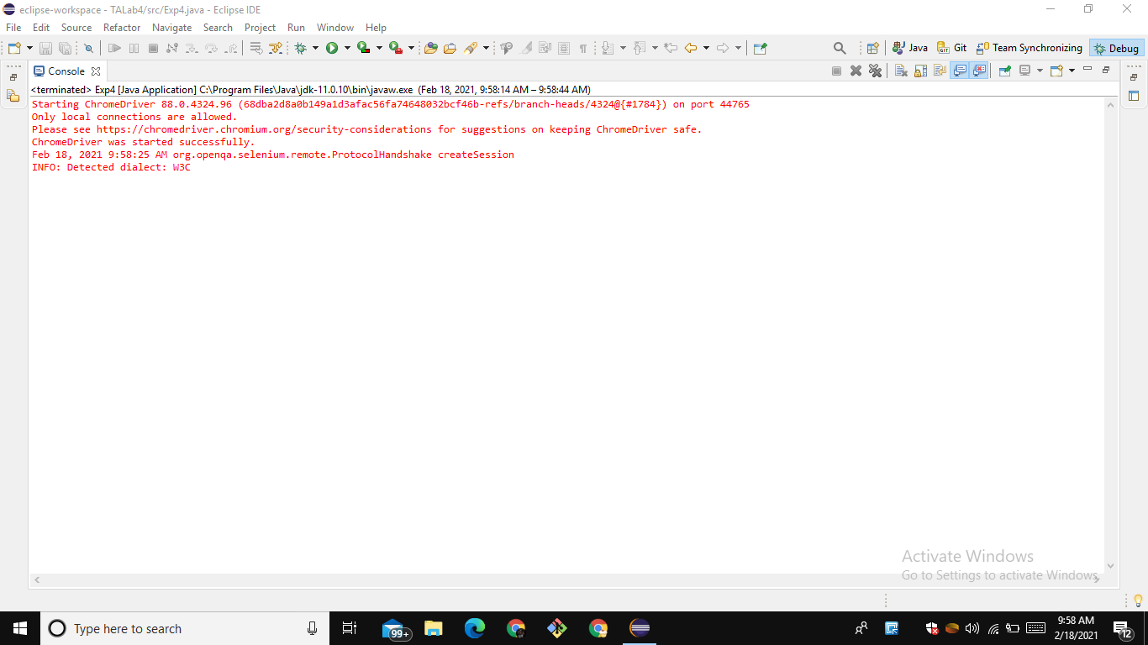

**EXPERIMENT – 5**

**Aim:** Build an automation script for navigating to the article details page and validate all the details for an article.

**Code:**

import static org.testng.Assert.*;

import java.util.ArrayList;

import org.openqa.selenium.By;

import org.openqa.selenium.WebDriver;

import org.openqa.selenium.WebElement;

import org.openqa.selenium.chrome.ChromeDriver;

public class Exp5{

public static void main(String[] args) throws InterruptedException {

System.setProperty("webdriver.chrome.driver", "C:\\Users\\dell\\Downloads\\Drivers\\chrome\\chromedriver.exe ");

WebDriver driver=new ChromeDriver();

driver.manage().window().maximize();

driver.navigate().to("https://www.amazon.in/");

WebElement searchbar = driver.findElement(By.id("twotabsearchtextbox"));

searchbar.sendKeys("Iphone 11 Pro");

WebElement searchbtn = driver.findElement(By.id("nav-search-submit-button"));

searchbtn.click();

WebElement smartphone = driver.findElement(By.linkText("Apple iPhone 11 Pro (64GB) - Space Grey"));

smartphone.click();

ArrayList<String> nTabs = new ArrayList<String>(driver.getWindowHandles());

System.out.println("no of Tabs " + nTabs);

driver.switchTo().window(nTabs.get(1));

//For MRP

WebElement price = driver.findElement(By.xpath("/html/body/div[4]/div[2]/div[2]/div[10]/div[12]/div/table/tbody/tr[1]/td[1]"));

System.out.println("price is "+ price);

String txt = price.getText();

System.out.println("Heading: " + txt);

assertTrue(txt.equalsIgnoreCase("M.R.P.:"));

//For Deal Price

String finalprice = driver.findElement(By.id("priceblock_dealprice_lbl")).getText();

System.out.println("Final Price:" + finalprice);

assertTrue(finalprice.contains("Deal"));

//Buy Now button

WebElement buy = driver.findElement(By.id("buy-now-button"));

System.out.println("Buy now button:"+ buy);

assertTrue(buy.isEnabled());

//For Add to cart button

WebElement cart = driver.findElement(By.id("add-to-cart-button"));

System.out.println("Add to cart button:"+ cart);

assertTrue(cart.isEnabled());

}}

**Screenshots:**

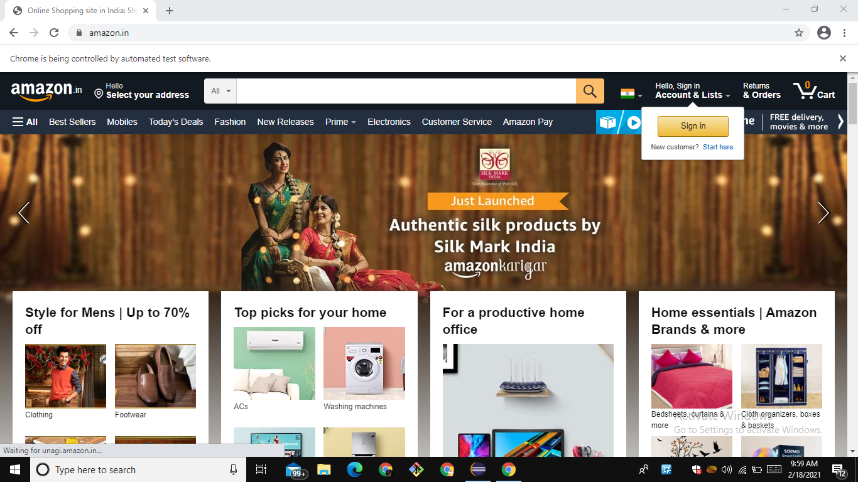

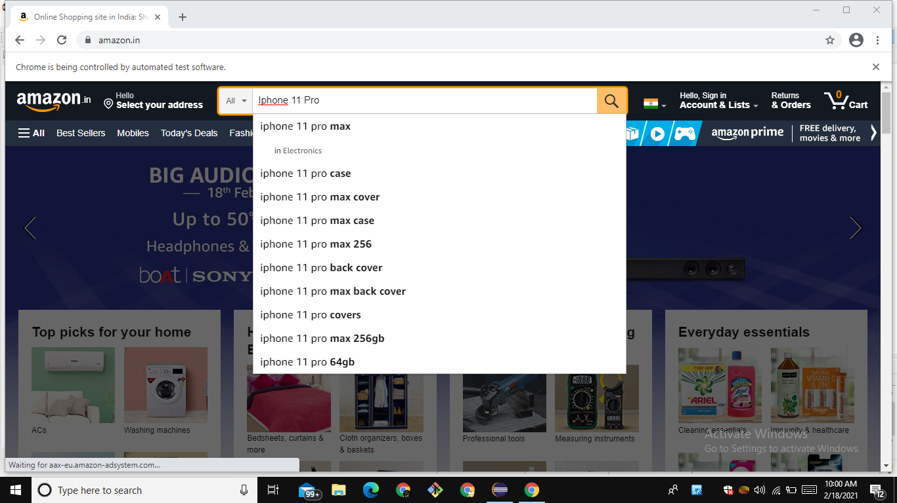

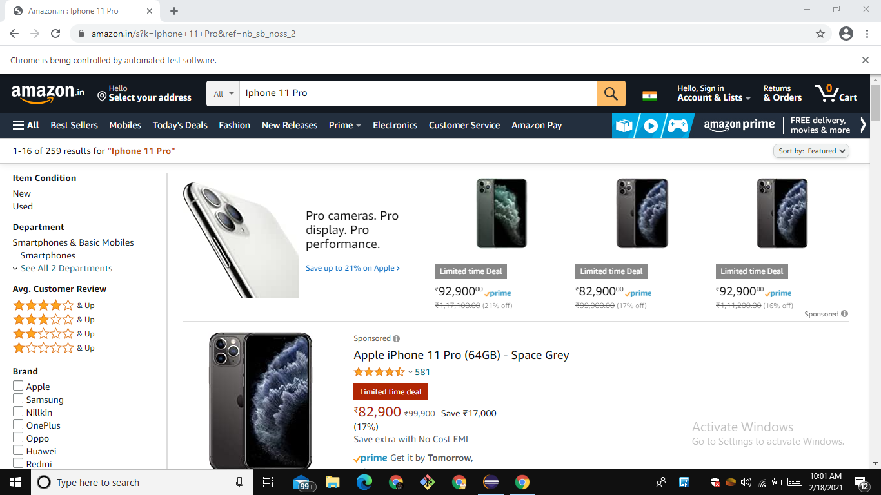

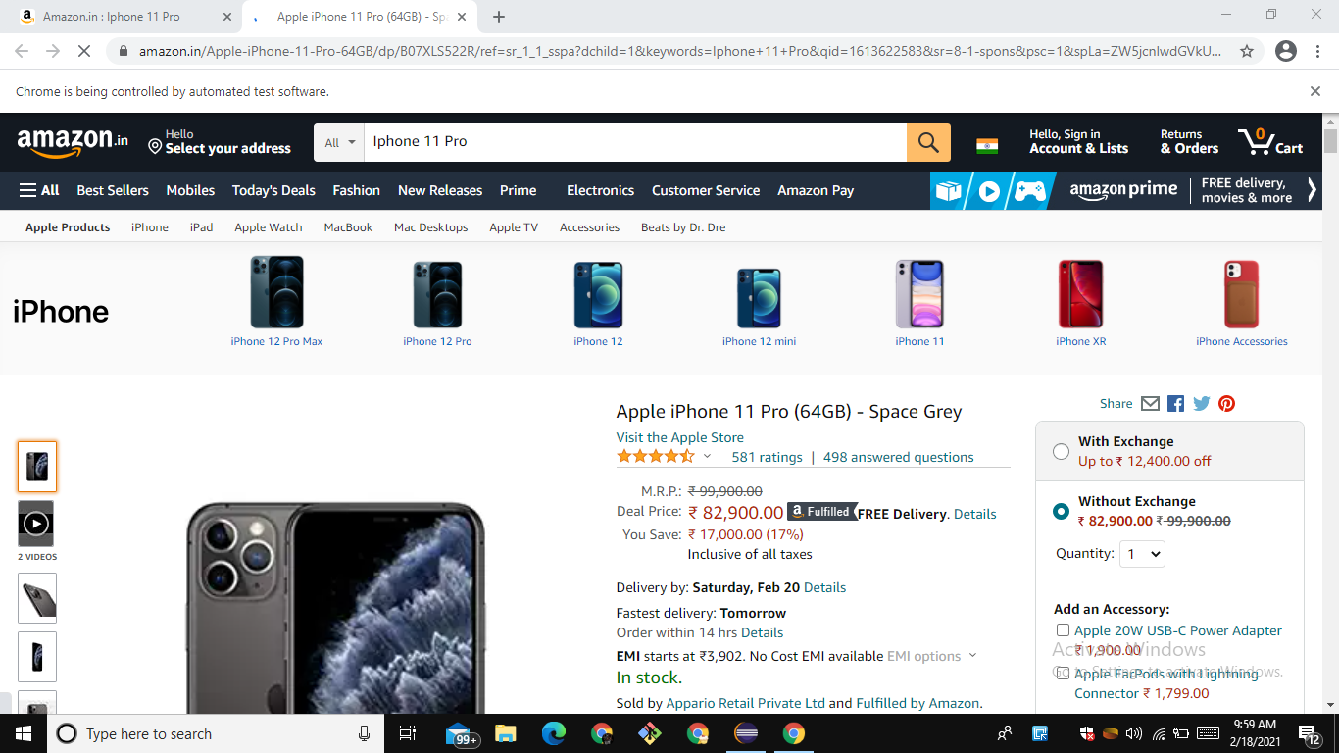

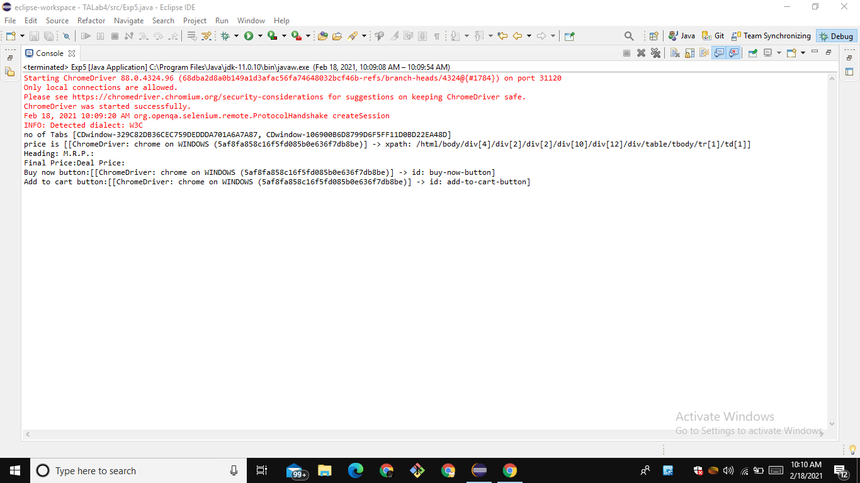

**EXPERIMENT – 6**

**Aim:** Refactor your test code for Login, Search Page and Article details page.

**1. LOGIN**

**Code:**

import org.testng.annotations.Test;

import org.testng.annotations.BeforeTest;

import static org.testng.Assert.assertTrue;

import org.openqa.selenium.By;

import org.openqa.selenium.WebDriver;

import org.openqa.selenium.WebElement;

import org.openqa.selenium.chrome.ChromeDriver;

import org.testng.annotations.AfterTest;

public class NewTest {

WebDriver driver;

String path="C:\\Users\\dell\\Downloads\\Drivers\\chrome\\chromedriver.exe ";

@BeforeTest

public void beforeTest() {

System.setProperty("webdriver.chrome.driver",path);

driver=new ChromeDriver();

driver.navigate().to("https://www.amazon.in/");

}

@Test(priority = 0)

public void func1() {

WebElement signin = driver.findElement(By.id("nav-link-accountList"));

assertTrue(signin.isEnabled());

signin.click();

}

@Test(priority = 1)

public void func2() {

WebElement emailaddress = driver.findElement(By.id("ap_email"));

assertTrue(emailaddress.isEnabled());

emailaddress.sendKeys("8077490375");

}

@Test(priority = 2)

public void func3() {

WebElement continuebutton = driver.findElement(By.id("continue"));

assertTrue(continuebutton.isDisplayed());

continuebutton.click();

}

@Test(priority = 3)

public void func4() {

WebElement password = driver.findElement(By.xpath("/html/body/div[1]/div[1]/div[2]/div/div[2]/div/div/div/form/div/div[1]/input"));

password.sendKeys("AbhisheK");

}

@Test(priority = 4)

public void func5() {

WebElement signin = driver.findElement(By.id("signInSubmit"));

assertTrue(signin.isDisplayed());

signin.click();

}

@AfterTest

public void afterTest() {

driver.close();

}

}

**Screenshots:**

1. Amazon website is up and running.

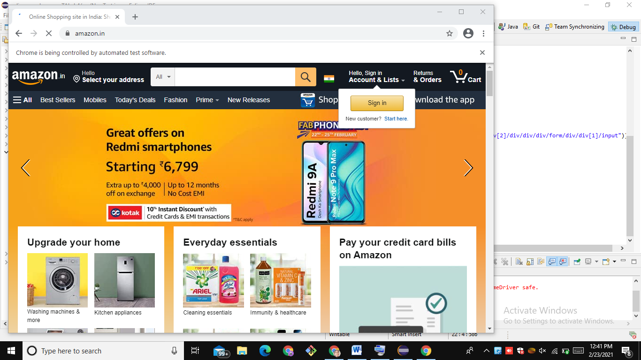

2. Login page is working.





3. Console Output

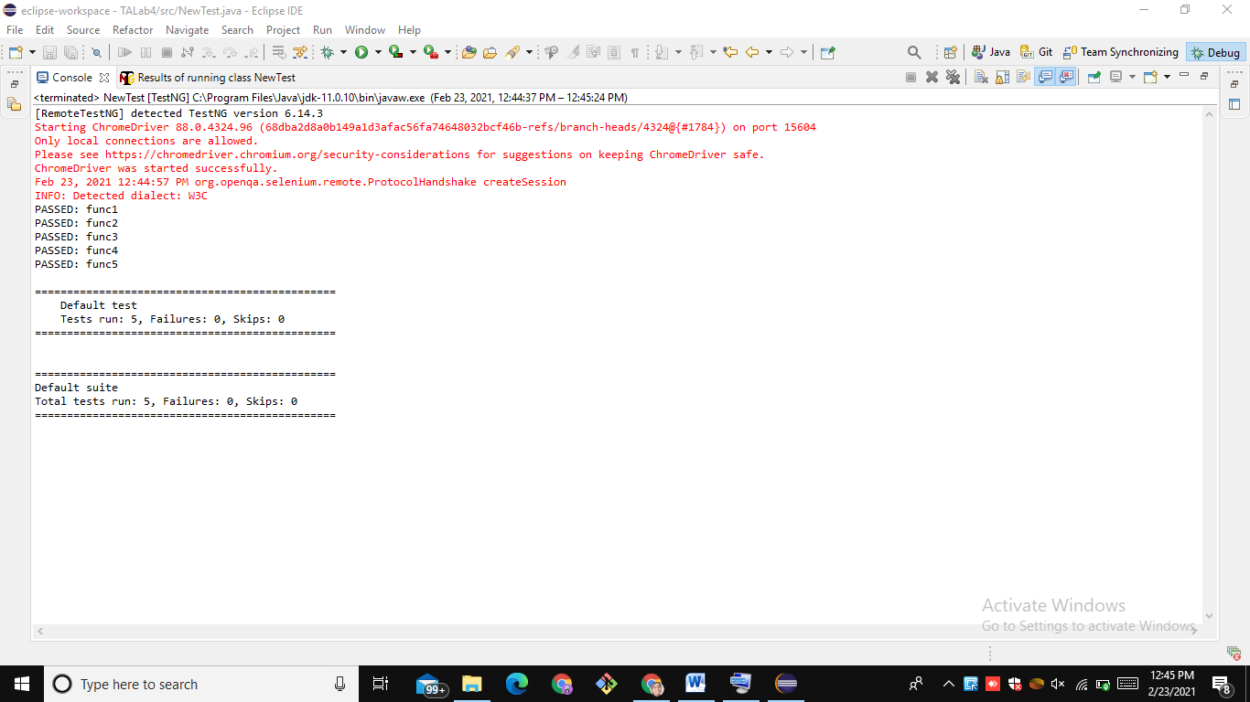

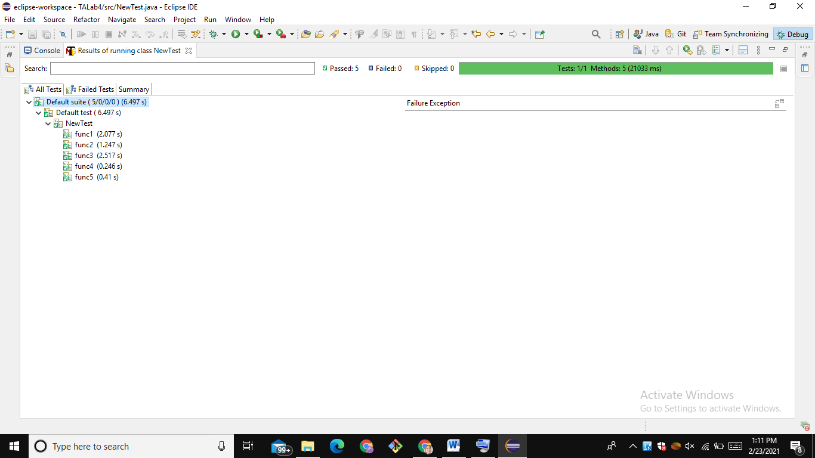

**2. REGISTER**

**Code:**

import static org.testng.Assert.assertTrue;

import org.openqa.selenium.By;

import org.openqa.selenium.WebDriver;

import org.openqa.selenium.WebElement;

import org.openqa.selenium.chrome.ChromeDriver;

import org.testng.Assert;

import org.testng.annotations.AfterTest;

import org.testng.annotations.BeforeTest;

import org.testng.annotations.Test;

public class Register {

WebDriver driver;

String path="C:\\Users\\dell\\Downloads\\Drivers\\chrome\\chromedriver.exe ";

@BeforeTest

public void beforeTest() {

System.setProperty("webdriver.chrome.driver",path);

driver=new ChromeDriver();

driver.navigate().to("https://www.amazon.in/");

}

@Test(priority = 0)

public void function1() {

WebElement signin = driver.findElement(By.id("nav-link-accountList"));

assertTrue(signin.isEnabled());

signin.click();

}

@Test(priority = 1)

public void function2() {

WebElement account = driver.findElement(By.id("createAccountSubmit"));

account.click();

}

@Test(priority = 2)

public void function3() {

WebElement Name = driver.findElement(By.id("ap_customer_name"));

Name.sendKeys("Abhishek Sharma");

}

@Test(priority = 3)

public void function4() {

WebElement contactno =

driver.findElement(By.id("ap_phone_number"));

assertTrue(contactno.isEnabled());

contactno.sendKeys("8077490375");

}

@Test(priority = 4)

public void function5() {

WebElement password = driver.findElement(By.id("ap_password"));

assertTrue(password.isEnabled());

password.sendKeys("AbhisheK");

}

@Test(priority = 5)

public void function6() {

WebElement continuebtn = driver.findElement(By.id("continue"));

assertTrue(continuebtn.isDisplayed());

continuebtn.click();

}

@AfterTest

public void afterTest() {

driver.close();

}

}

**Screenshots:**

1. Amazon website is up and running

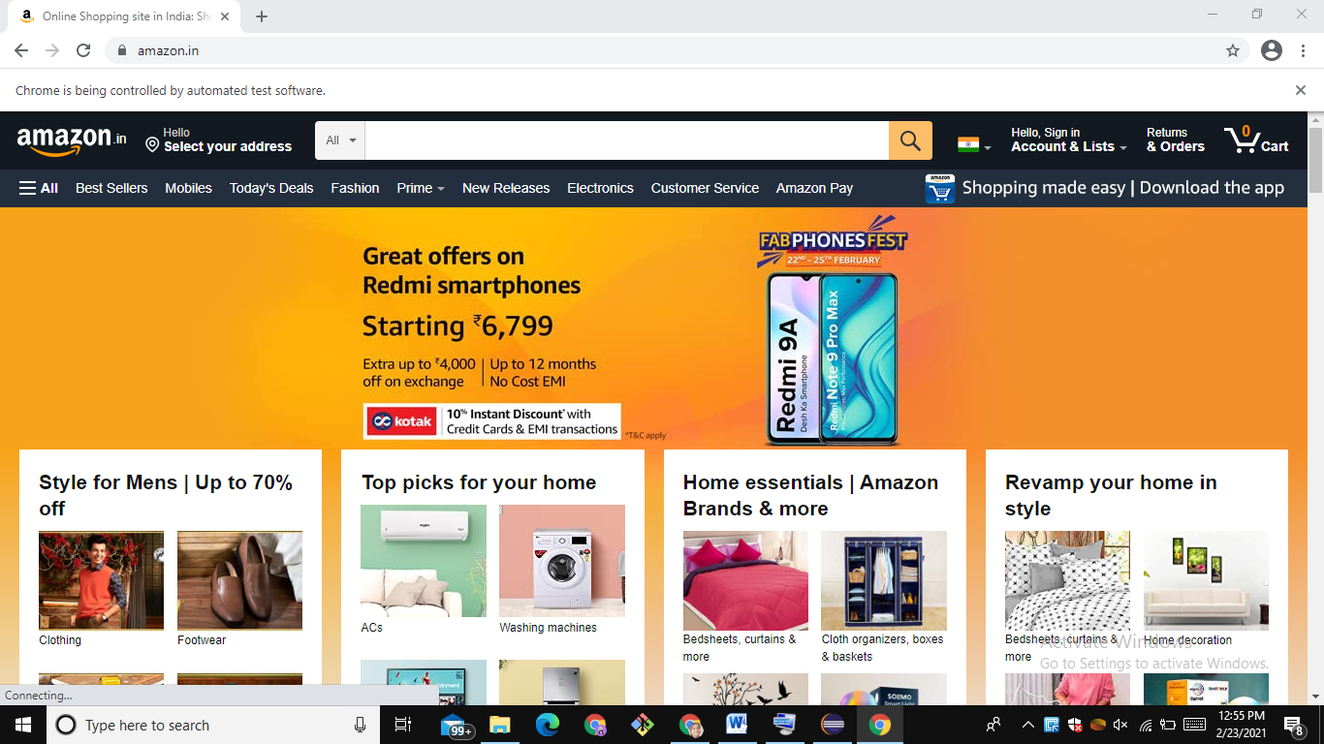

2. Login Page is working

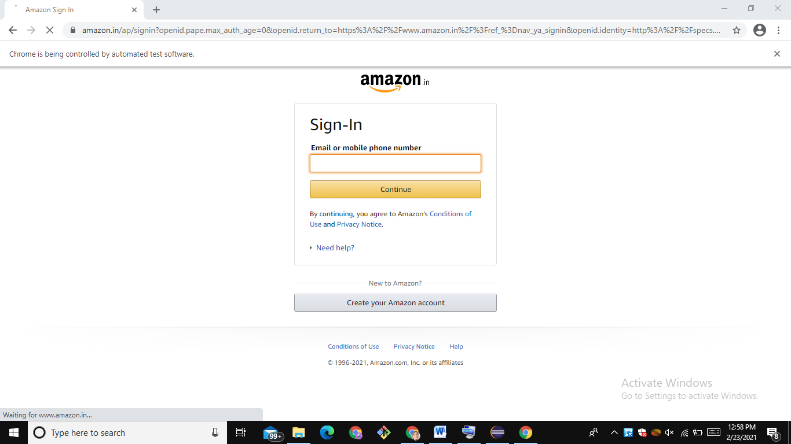

3. Adding the details



4. Console Output

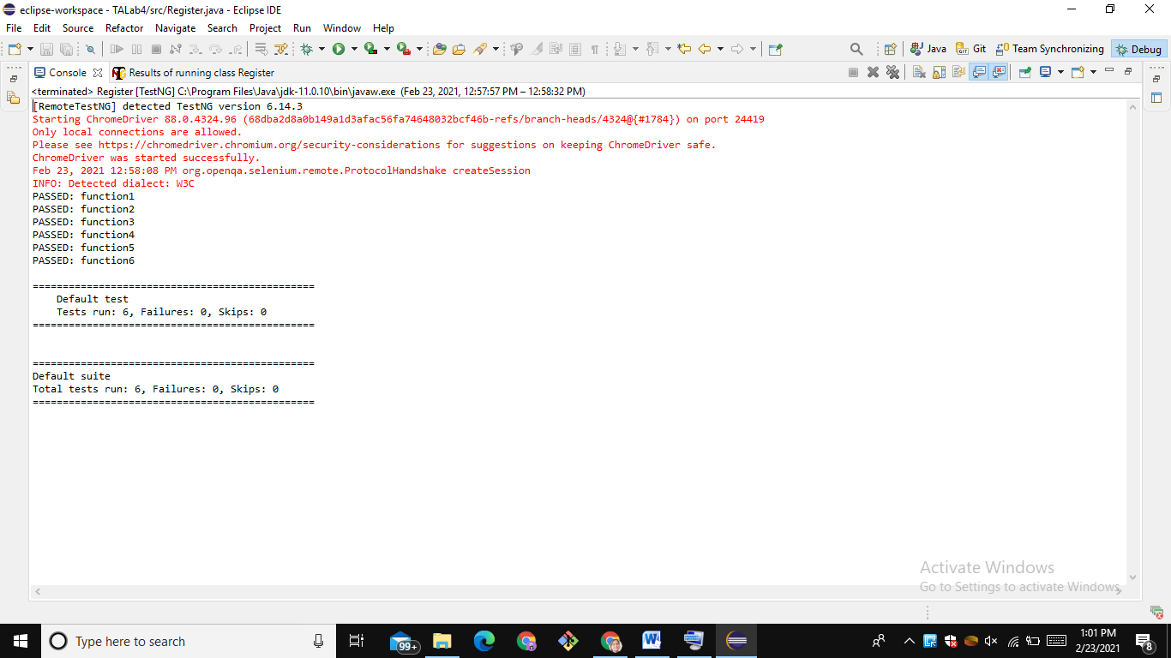

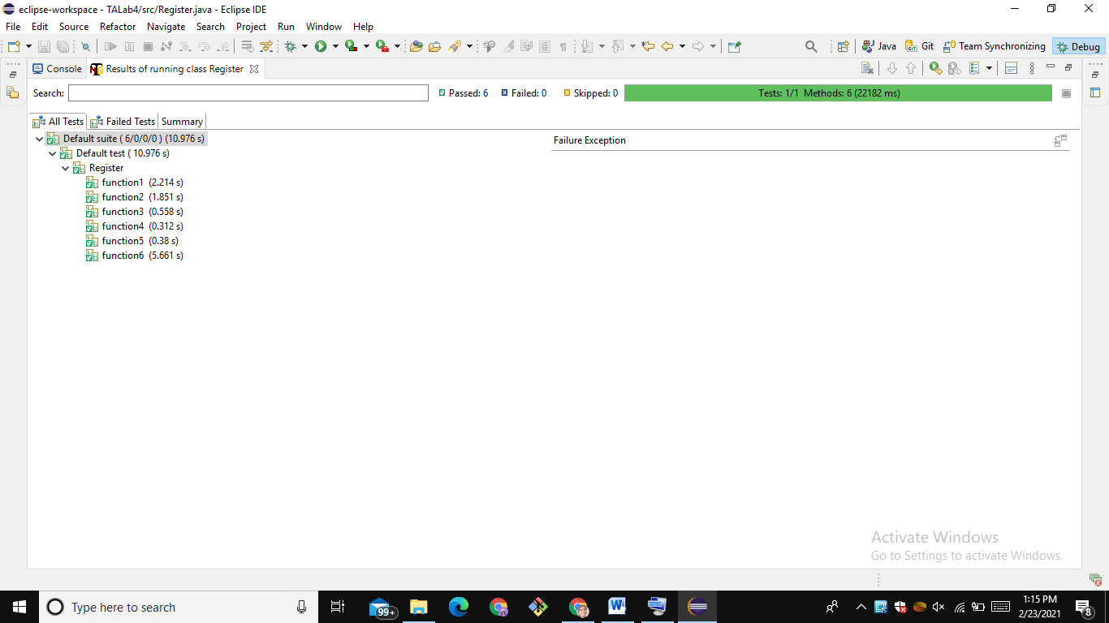

**3. SEARCH**

**Code:**

import static org.testng.Assert.assertTrue;

import org.openqa.selenium.By;

import org.openqa.selenium.WebDriver;

import org.openqa.selenium.WebElement;

import org.openqa.selenium.chrome.ChromeDriver;

import org.testng.annotations.AfterTest;

import org.testng.annotations.BeforeTest;

import org.testng.annotations.Test;

public class Search {

WebDriver driver;

String path="C:\\Users\\dell\\Downloads\\Drivers\\chrome\\chromedriver.exe ";

@BeforeTest

public void beforeTest() {

System.setProperty("webdriver.chrome.driver",path);

driver=new ChromeDriver();

driver.navigate().to("https://www.amazon.in/");

}

@Test(priority = 0)

public void function1() {

WebElement searchbox =

driver.findElement(By.xpath("/html/body/div[1]/header/div/div[1]/div[2]/div/form/div[2]/div[1]/input"));

assertTrue(searchbox.isEnabled());

searchbox.sendKeys("Iphone 11 Pro");

}

@Test(priority = 1)

public void function2() {

WebElement searchbutton = driver.findElement(By.xpath("/html/body/div[1]/header/div/div[1]/div[2]/div/form/div[3]/div/span/input"));

assertTrue(searchbutton.isEnabled());

searchbutton.click();

}

@Test(priority = 2)

public void function3() {

WebElement product = driver.findElement(By.linkText("Apple iPhone 11 Pro (64GB) - Space Grey"));

assertTrue(product.isDisplayed());

}

@Test(priority = 3)

public void function4() {

WebElement price =

driver.findElement(By.xpath("/html/body/div[1]/div[2]/div[1]/div[2]/div/span[3]/div[2]/div[2]/div/span/div/div/div/div/div[2]/div[2]/div/div[2]/div[1]/div/div[1]/div[2]/div/div/a/span[1]/span[2]/span[2]"));

assertTrue(price.isDisplayed());

}

@Test(priority = 4)

public void function5() {

WebElement image =

driver.findElement(By.xpath("/html/body/div[1]/div[2]/div[1]/div[2]/div/span[3]/div[2]/div[2]/div/span/div/div/div/div/div[2]/div[1]/div/div/span/a/div/img"));

assertTrue(image.isDisplayed());

}

@AfterTest

public void afterTest() {

driver.close();

}}

**Screenshots:**

1. Item is searched.

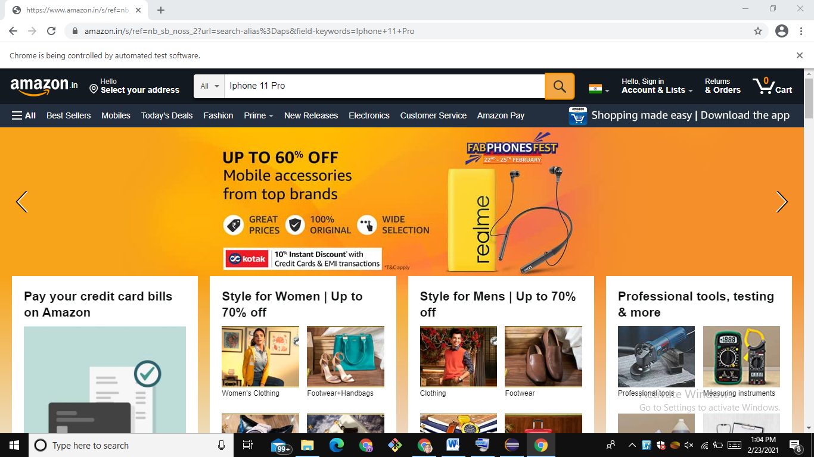

2. Results are displayed.

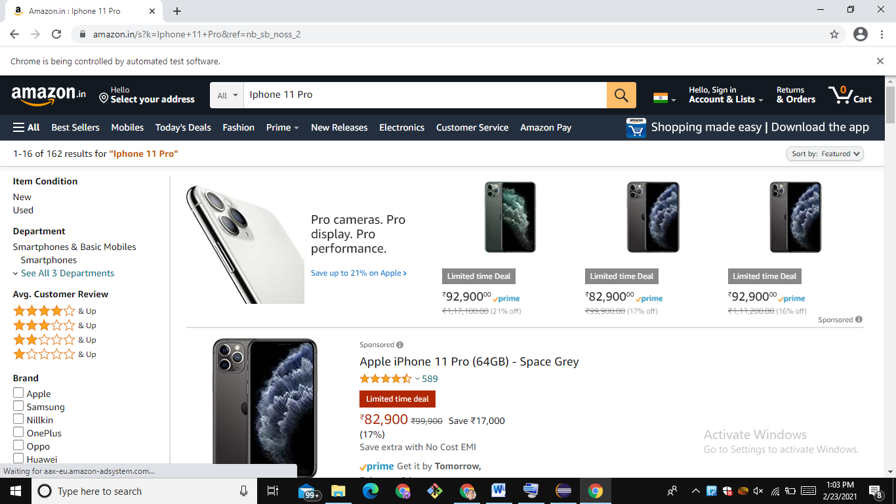

3. Console Output

